Zid’Avwa Al Bari’i
244107020083 / TI – 2I / 26

Jobsheet 7

Exercise 1

Codes
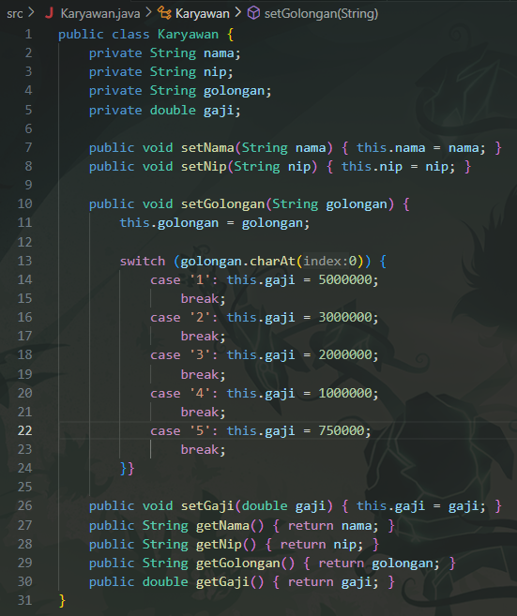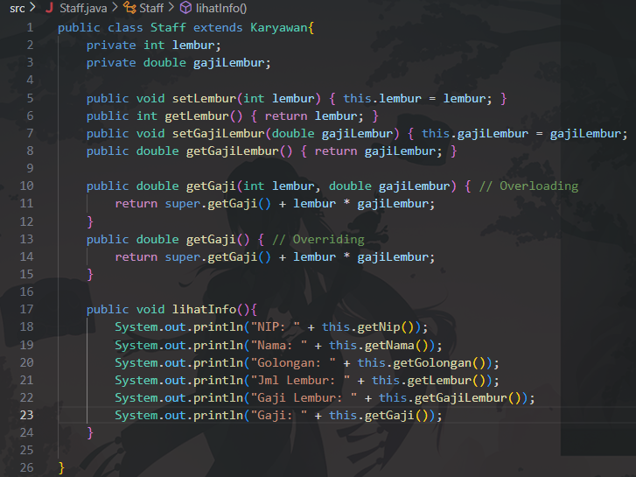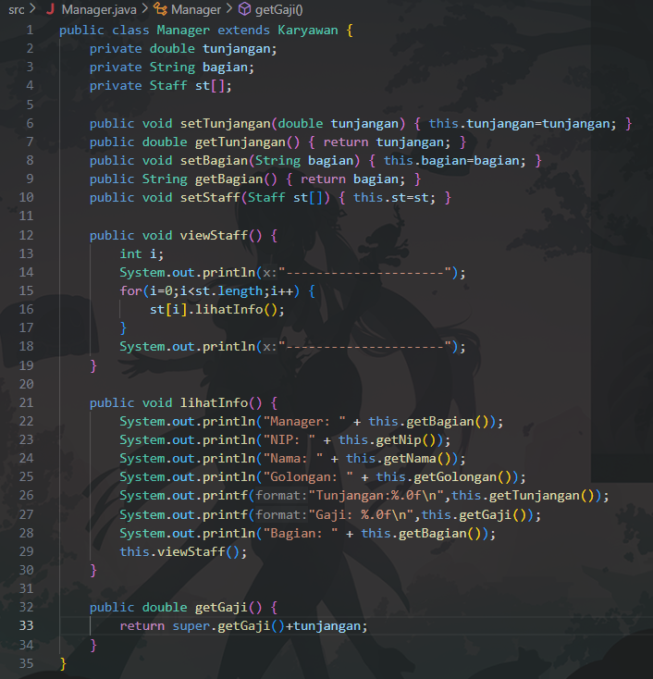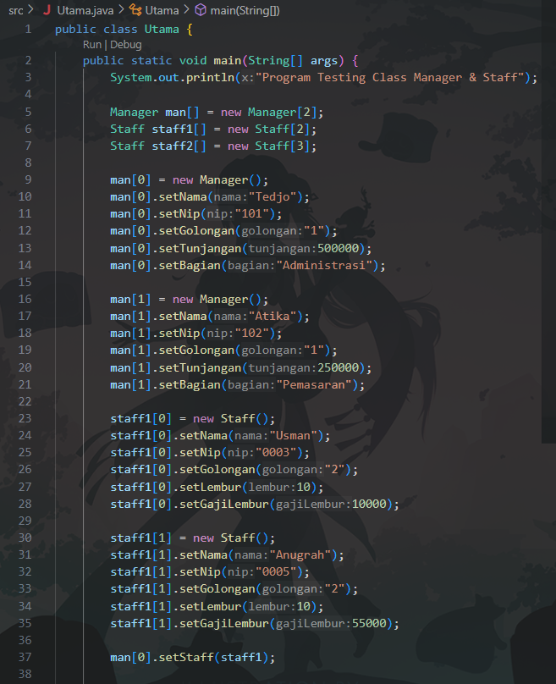
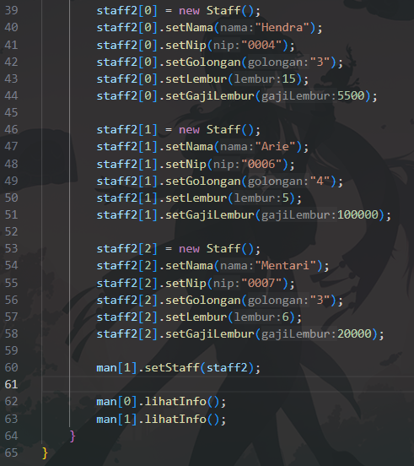

Questions & Answers:
- Where is the overloading?
The overloading occurs in the two perkalian() methods, where one has two parameters (int a, int b) and the other has three parameters (int a, int b, int c).
- How many different parameters are there?
There are 2 different parameter variations:
- perkalian(int, int)
- perkalian(int, int, int)
- Where is the overloading?
The overloading occurs in the perkalian() methods where one uses integer parameters (int a, int b) and the other uses double parameters (double a, double b), but with the same method name.
- How many different types of parameters are there?
There are 2 different data types:
- int, int
- double, double
- Where is the overriding?
The overriding happens in the Piranha class, where the method: public void swim() overrides the same swim() method from the Ikan class.
- Describe the source coding if there is overriding.
Overriding means the subclass (Piranha) provides a new implementation of a method that already exists in its superclass (Ikan) using the same method name and parameters. When the method is called through an object of the subclass, the subclass version is executed (polymorphism).

TASKS

Overloading
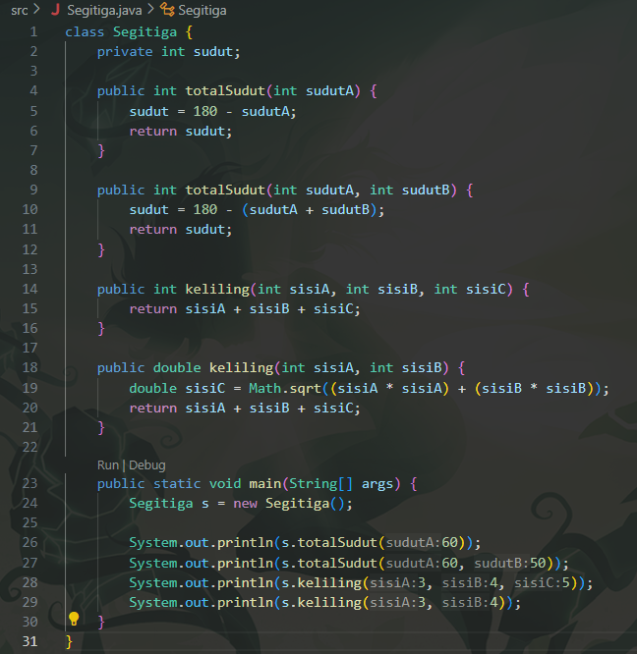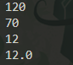

Overriding
